**PRACTICAL – 12.1**

**Aim:** Create two 2D Numpy arrays with random numbers and concatenate them using the Numpy library. After Concatenation, reshape the resulting Numpy array such that the number of rows and columns is reversed.

**PROGRAM:**

|  |
| --- |
| import numpy as np  # creating two 2D arrays  arr1 = np.arange(1, 10).reshape(3, 3)  arr2 = np.arange(10, 19).reshape(3, 3)  print(arr1)  print("\n", arr2)  # concating operations (axis 1 for column, 0 for row)  np.concatenate((arr1, arr2), axis=1)  print("\n20DCE019 - Yatharth Chauhan") |

**OUTPUT:**

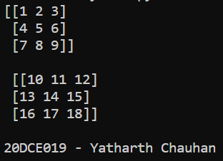

**CONCLUSION:** In this practical, we learned to use Numpy Arrays and concatenate those together.

**PRACTICAL – (12.2)**

**AIM: Create a Pandas series from a Python List. Find out the mean, median, mode, range and standard deviation of the series.**

**PROGRAM:**

|  |
| --- |
| import pandas as pd  s = pd.Series(data=[5, 9, 8, 7, 8, 1, 2, 3, 4, 5, 6, 7, 8, 9, 5, 3])  print(s)  print("-----------------------------")  print("Mean value is ", s.mean())  print("-----------------------------")  print("Standard Deviation value is ", s.std())  print("-----------------------------")  print("Median value is ", s.median())  print("-----------------------------")  print("Mode value is ", s.mode())  print("\n20DCE019 - Yatharth Chauhan") |

**OUTPUT:**

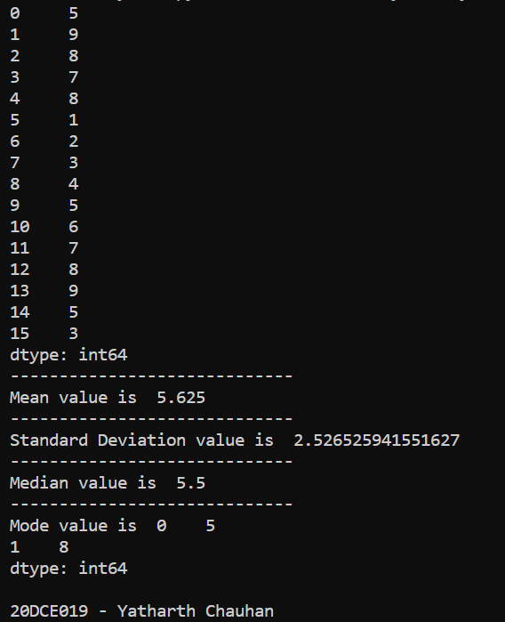

**CONCLUSION:** In this Practical, we learned about Panda series from Python List to perform mathematical operations.